**Dummies install for KW Redux**

1. **Download the Mod from either of these locations**

<http://spacedock.info/mod/531/KW%20Rocketry%20Redux>

<https://github.com/linuxgurugamer/KWRocketryRedux/releases>

1. **Unzip the package into a temporary directory, Windows users can use their download directory, you should have a folder like this.**



**With these folders**

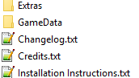

1. **Copy The GameData folder to the Gamedata folder of your KSP Install folder**

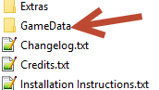

**3a.This one**

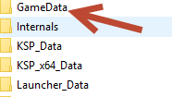

1. **I know what you’re thinking "Let’s fire up KSP and go launch something" well it’s not that simple, you have to make a choice. If you look at the folders in step 2 you will see an extras folder. It contains the following folders**

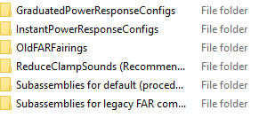

1. **You have by default the Graduated Power Config.  If you would like the Instant Power Config, follow the instructions below the green arrow indicates the installed Config**

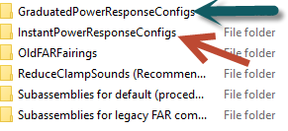

**Open the selected Instant Power config and select the GameData Folder**



**Copy this to the same folder in 3a**

**Optional**

**If you want to have the interstage engine shrouds working delete KWPatch -interstage.cfg from within KWCommunityFixes folder that’s inside the KWRocketry folder inside the GameData folder in 3a**

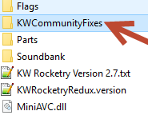

**This one**

